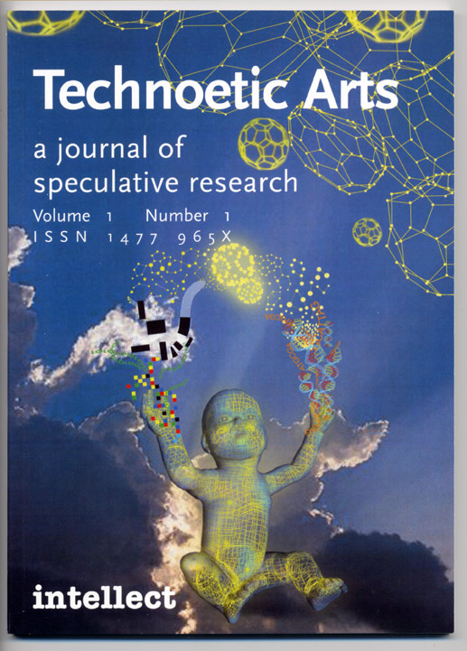

The Nanomeme Syndrome: Blurring of fact & fiction in the construction of a new science

Jim Gimzewski and Victoria Vesna

Abstract
In both the philosophical and visual sense, ‘seeing is believing’ does not apply to nanotechnology, for there is nothing even remotely visible to create proof of existence. On the atomic and molecular scale, data is recorded by sensing and probing in a very abstract manner, which requires complex and approximate interpretations. More than in any other science, visualization and creation of a narrative becomes necessary to describe what is sensed, not seen. Nevertheless, many of the images generated in science and popular culture are not related to data at all, but come from visualizations and animations frequently inspired or created directly from science fiction. Likewise, much of this imagery is based on industrial models and is very mechanistic in nature, even though nanotechnology research is at a scale where cogs, gears, cables, levers and assembly lines as functional components appear to be highly unlikely. However, images of mechanistic nanobots proliferate in venture capital circles, popular culture, and even in the scientific arena, and tend to dominate discourse around the possibilities of nanotechnology. The authors put forward that this new science is ultimately about a shift in our perception of reality from a purely visual culture to one based on sensing and connectivity.

Micromegas, a far better observer than his dwarf, could clearly see that the atoms were talking to one another; he drew the attention of his companion, who, ashamed at being mistaken in the matter of procreation, was now very reluctant to credit such a species with the power to communicate. (Voltaire, 1729 pg. 24)

Introduction
Nanotechnology is more a new science than technology, and the industry being constructed around it, predictably uses old ideas and imagery. During its current rise to prominence, a strange propagandist “nanometer” has emerged in our midst without being clearly realized by any of the participants. It is layered with often highly unlikely ideas of nanotech products that range from molecular sensors in underwear, smart washing machines that know how dirty the clothes are, to artificial red blood cells and nanobots that repair our bodies, all the way up to evil swarms of planet-devouring molecular machines. Sensation-based media happily propagates this powerful and misleading cocktail combining scientific data, graphically intense visualizations together with science fiction artwork. In the past few years, mixed up nanomemes have emerged, where the differences between science fiction novels, front cover stories and images of reputable journals such as Science or Nature are becoming differentiated by the proportion of fiction to fact rather than straight factual content.
Venture capitalists, the military, governments around the world as well as educational institutions seduced by this syndrome are portraying nanotech as the savior of our rapidly declining economies and outdated military systems. Dovetailing on the recent frenzied exponential rise and fall of information technologies, and also to a degree by biotechnology, the need for a new cure-all has been identified.
Two terms often used interdependently are nanoscience and nanotechnology. Surprisingly, the term nanotechnology predates nanoscience. This is because the dreams of a new technology were proposed before the actual scientific research specifically aimed at producing the technology existed. The term nanotechnology, in its short lifetime, has attracted a variety of interpretation, and there is little agreement, even among those who are engaged in it, as to what it actually is. Typically, it is described as a science that is concerned with control of matter at the scale of atoms and molecules. Nano is Greek for dwarf and a nanometer (nm) is one billionth of a meter, written in scientific notation as 1 x 10⁻⁹ m. Historically, the word nanotechnology was first proposed in the early seventies by a Japanese engineer, Norio Taniguchi, implying a new technology that went beyond controlling materials and engineering on the micrometer scale that dominated the 20th Century. [1]
One thing is certain however – as soon as we confront the scale that nanotechnology works within, our minds short circuit. The scale becomes too abstract in relation to human experience. Consequently, any intellectual connection to the nanoscale becomes extremely difficult. Scientists have tried to explain this disparity by comparing the nanometer to the thickness of a human hair: the average thickness of a human hair is ~5 x 10⁻⁵m, which is (50,000) nm. Or, the little fingernail: around 1 cm across, which is equal ten million nanometers. Recently, Nobel Laureate Sir Harry Kroto described the nanometer by comparing the size of a human head to that of the planet earth -- a nanometer would be the size of a human head in relation to the size of the planet if the planet were the size of the human head. [2] But, even that is difficult to intuitively grasp or visualize. What type of perceptual shift in our minds has to take place to comprehend the work that nano science is attempting and what would be the repercussions of such a shift? And, how does working on this level influence the way scientists think who engage this work? In our opinion, media artists, nano-scientists and humanists need to join forces together and envision such possibilities. [3]
On another level, as a metric, the nanometer itself does not do justice in describing nanotechnology, but is rather the starting point of understanding complexity. Even the concept of precise fabrication at the ultimate limits of matter does nanotechnology injustice because it implies an industrial engineering model. When working on this kind of scale, we immediately reach the limits of rational human experience, and the imaginary takes over. Researchers, science fiction writers and Luddites alike have gone into overdrive with the fantasies associated with the world driven by nanotechnology. One prevalent fear is mind control, while the dream is, as always, of immortality and power.
By some mysterious juxtaposition of events, the beginning of the 21st century is symbolized by the decoding of the genome, fears of distributed terrorist cells and nanotechnology as the big promise of total control of matter from the atom all the way up living systems. In the last ten years alone, over 455 companies based on nanotechnology have been formed in Europe, US and Japan, 271 major universities are involved in nanotech research and 95 investment companies are focusing on this new science. Over 4 billion dollars has been invested globally in nanoscience in 2001 and the bar is being raised. [4]. But, unlike infotech and to a degree, biotech, nanotech is very much in its infancy of development and principally in the research phase. Perhaps this is what makes it so attractive to such a varied audience – the field is wide open for visionaries and opportunists alike, representing new uncharted territory resembling the early stages of space exploration of the 20th century and mission oriented approaches to science and technology. Indeed, NASA foresees this potentially disruptive technology as being instrumental in exploring space to answer such questions, as “Are we alone in this universe?” [5]
Although nanotechnology is used widely to refer to something very tiny, this new science will eventually revolutionize and impact every single aspect of our lives. It will do this on all scales all the way up from the atom to the planet earth and beyond. The very modus operandi of science is already changing under its influence. Nanoscience not only requires input from practically every scientific discipline, but it also needs direct and intense collaboration with the humanities and the arts. It is highly probable that this new technology will turn the world, as we know it, upside down, from the bottom up.
Richard Feynman is often credited as the person who initiated the conceptual underpinnings of nano technology, before the term was coined. Although many physicists who were working in the quantum realm arrived at perhaps similar conclusions, his lecture, “There is Plenty of Room at the Bottom, ”in 1959, is used as a historical marker for the conceptualization of nanoscience and technology. Indeed, it is interesting to note that this was not an invention per se, but more a shift of focus or attention generated by a flamboyant personality that is interpreted to initiate the advent of nanotechnology. [6]
Much of Feynman’s visions really took hold in the early eighties when nano science and technology truly took off. In 1981, Heinrich Rohrer and Gerd Binning, at IBM Zurich research laboratories, invented the Scanning Tunneling Microscope (STM), which for the first time “looked” at the topography of atoms that cannot be seen. (Binning) With this invention, the age of the immaterial was truly inaugurated. Not much later, in 1984, a molecule was discovered by Sir Harry Kroto, Richard Smalley and Robert Curl that truly got the ball rolling. Buckminsterfullerene named after Buckminster Fuller, an architect, engineer, philosopher whose dome structures employed geometries found in natural structures. (Applewhite) Not coincidentally, the IBM PC was taking center stage and causing a true revolution in arts and sciences alike. In a short period of history, many new things appeared, creating a perfect environment for a natural symbiosis between science, technology and art. Another decade would pass before people occupying these creative worlds would expand their perceptual field to include each other’s points of views. Indeed, the surge of this expansion happened from a genuine need to embrace and cross-polinate research and development between science, technology and art.

New Vision: the STM – a symbol of the shift from visual to tactile perception
Up until the mid-nineteen eighties, scientists viewed matter, atoms, molecules, and solids using various types of microscopes or in abstract space (Fourier Space). The wide spread use of optical microscopes had begun in the 17th Century, enabling people like Galileo to investigate matter through magnification by factors of hundreds. These microscopes relied on lenses and the properties of light as a wave. Waves were manipulated by lenses to magnify and create an image in the viewer’s eye, providing information on how light is reflected or transmitted through an object. [7]
Typically, human perception of a microscope is a tube-like structure through which one looks and sees reality magnified. In a deeper philosophical sense, while being strictly scientific, the concept of “seeing” is illusory. Nevertheless, when one looks through a microscope at a butterfly’s wings, it is difficult to separate ones’ conscious mind and its interpretation from the information transmitted by ones’ eyes. The eye itself contains a small part of the brain that already preprocesses the information received as light particles, or waves. As the magnifying power of the microscope increased, the average person looking through the lenses maintains his or her illusion of seeing a reality, and interprets the image in terms of common human experience related to the scale in which one normally observes the world.
The Scanning Tunneling Microscope [8] represents a paradigm shift from seeing in the sense of viewing, to tactile sensing -- recording shape by feeling, much like a blind man reading Braille. The operation of a STM is based on a quantum electron tunneling current, felt by a sharp tip in proximity to a surface at a distance of approximately one nanometer. The tip is mounted on a three dimensional actuator like a finger as shown schematically in Figure. 1. This sensing is

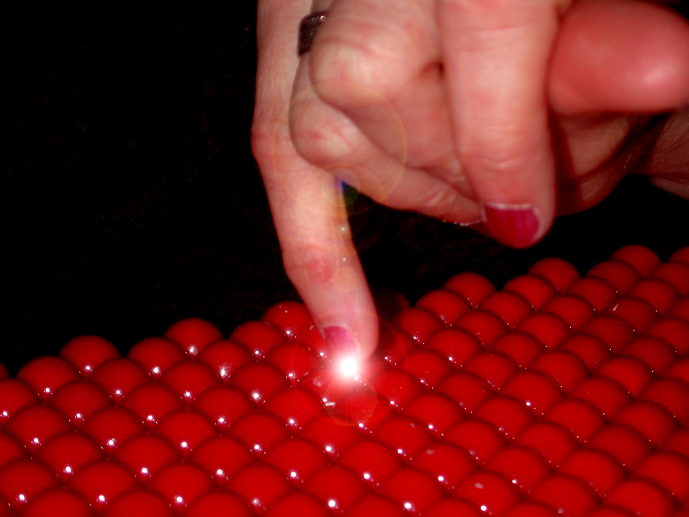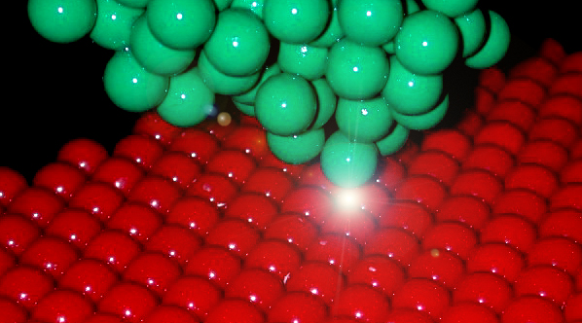

Figure 1. Principle of a scanning tunneling microscope uses a local probe: The gentle touch of a nanofinger is shown in (a) where if the human finger was shrunk by about ten millions times it would be able to feel atoms represented here by spheres 1 cm in diameter. If the interaction between tip and sample decays sufficiently rapidly on the atomic scale, only the two atoms that are closest to each other are able to ‘‘feel’’ each other as shown in (b) where the human finger is replaced by an atomically sharp tip. Binnig and Rohrer (1999) inspired this explanation of the STM.

recorded as the tip is mechanically rastered across the surface producing contours of constant sensing (in the case of STM this requires maintaining a constant tunneling current). The resulting information acquired is then displayed as an image of the surface topography. [fig. 2] Through images constructed from feeling atoms with an STM, an unconscious connection to the atomic world quickly becomes automatic to researchers who spend long periods of time in front of their STMs. This inescapable reaction is much like driving a car – hand, foot, eye, and machine coordination becomes automated. Similarly, the tactile sensing instrument soon became a tool to manipulate the atomic world by purposefully moving around atoms and molecules and recording the effect which itself enabled exploration of interesting new physical and chemical processes on an molecule –by- molecule basis. [9] [figure 3]
In science, commonly agreed human perceptions are constantly in question. Indeed, as the power of the 20th Century microscopes increased, the images recorded progressively reflected not only patterns of waves determined by physical object form, but also how the light waves scatter and interfere with each other. The butterfly's blue wings no longer have color -- one finds the color to be an illusion - a beautiful illusion – where form, shape and periodic patterns on the nanoscale manipulate light waves to provide us with the illusion of seeing blue. (Ghiradella) As the magnification increases, we can no longer rely on our common human perception. Rather we see how, in this case, nature has carefully duped us -- how through some magnificent evolutionary process, she has generated what is called nanophotonics. (Yablonovitch) Nanophotonics is a way to manipulate light through shapes, not mirrors. Indeed, by just changing the physical structure of matter on the nanoscale, we can produce a mirror, a mirror that is perfect; a mirror that some time in the future, through voice command, will switch to become a window. As we increase magnification into the truly invisible realm, we change our perception to view the world around us as an abstraction, a pattern of light waves. We apply mathematical principles based on fundamental rules for the way light intensifies with itself and object form. From this analysis comes an interpretation, perhaps as a mathematical reconstruction of reality.

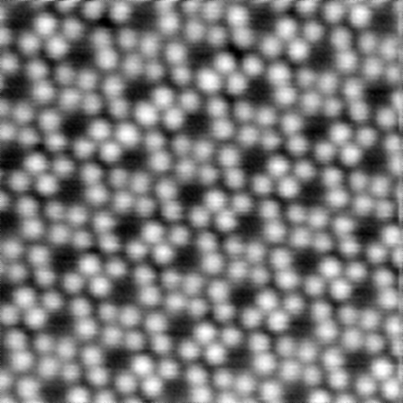
Figure 2. The STM records images of surfaces and molecules as a two dimensional data set of heights. Here an ordered array of molecules called hexa-butyl decacyclene, each around 1 nanometer is size were recorded by the STM. The resulting data were then plotted as a gray scale image representing the apparent height of the molecules. Each molecule is represented as six lobes in a distinct hexagonal pattern with a dark central portion. Interestingly this height maps does not represent the real height of the atoms but rather the probability of parts of the molecule to convey electrons by quantum tunneling to the tip. The casual observer tends to see the pattern as representing the shape of the molecule. (Gimzewski et al; unpublished data)

Both nanotechnology and media arts, by their very nature, have a common ground in addressing the issues of manipulation, particularly sensory perception, questioning our reaction, changing the way we think. They are complementary, and the issues that are raised start to spill over into fundamental problems of the limits of psychology, anthropology, biology and so on. It is as if the doors of perception have suddenly opened and the microscope’s imperfection of truly representing object form forces us to question our traditional (Western) values of reality.

Magnification – On the edge of reality
Scientists progressively turned up the magnification, but no matter how good the glass lenses were, how precise the brass tubes and screws were, at around x10, 000, the image goes fuzzier until, at x100, 000, the image is basically blank. This is called “the Raleigh limit”, which says you cannot see anything with using a wave that is smaller than half the size of the wave. In other words, this light wave has a size just like an ocean wave has the distance between its crests. The length of the wave is the feature that limits what we “see” which has a limit when we use regular light of two hundred nanometers. It is already twice the size of a wire in a Pentium IV, or a few hundred times thinner than a hair -- it is back to the metric. To get higher magnification, scientists used shorter waves and even the wave properties of electrons. Nevertheless, despite the progress, the high energies and conditions required to make these higher resolution images started to destroy the very objects they wanted to “see”. In effect, they ended up looking at matter using something like a focused blowtorch in a vacuum.

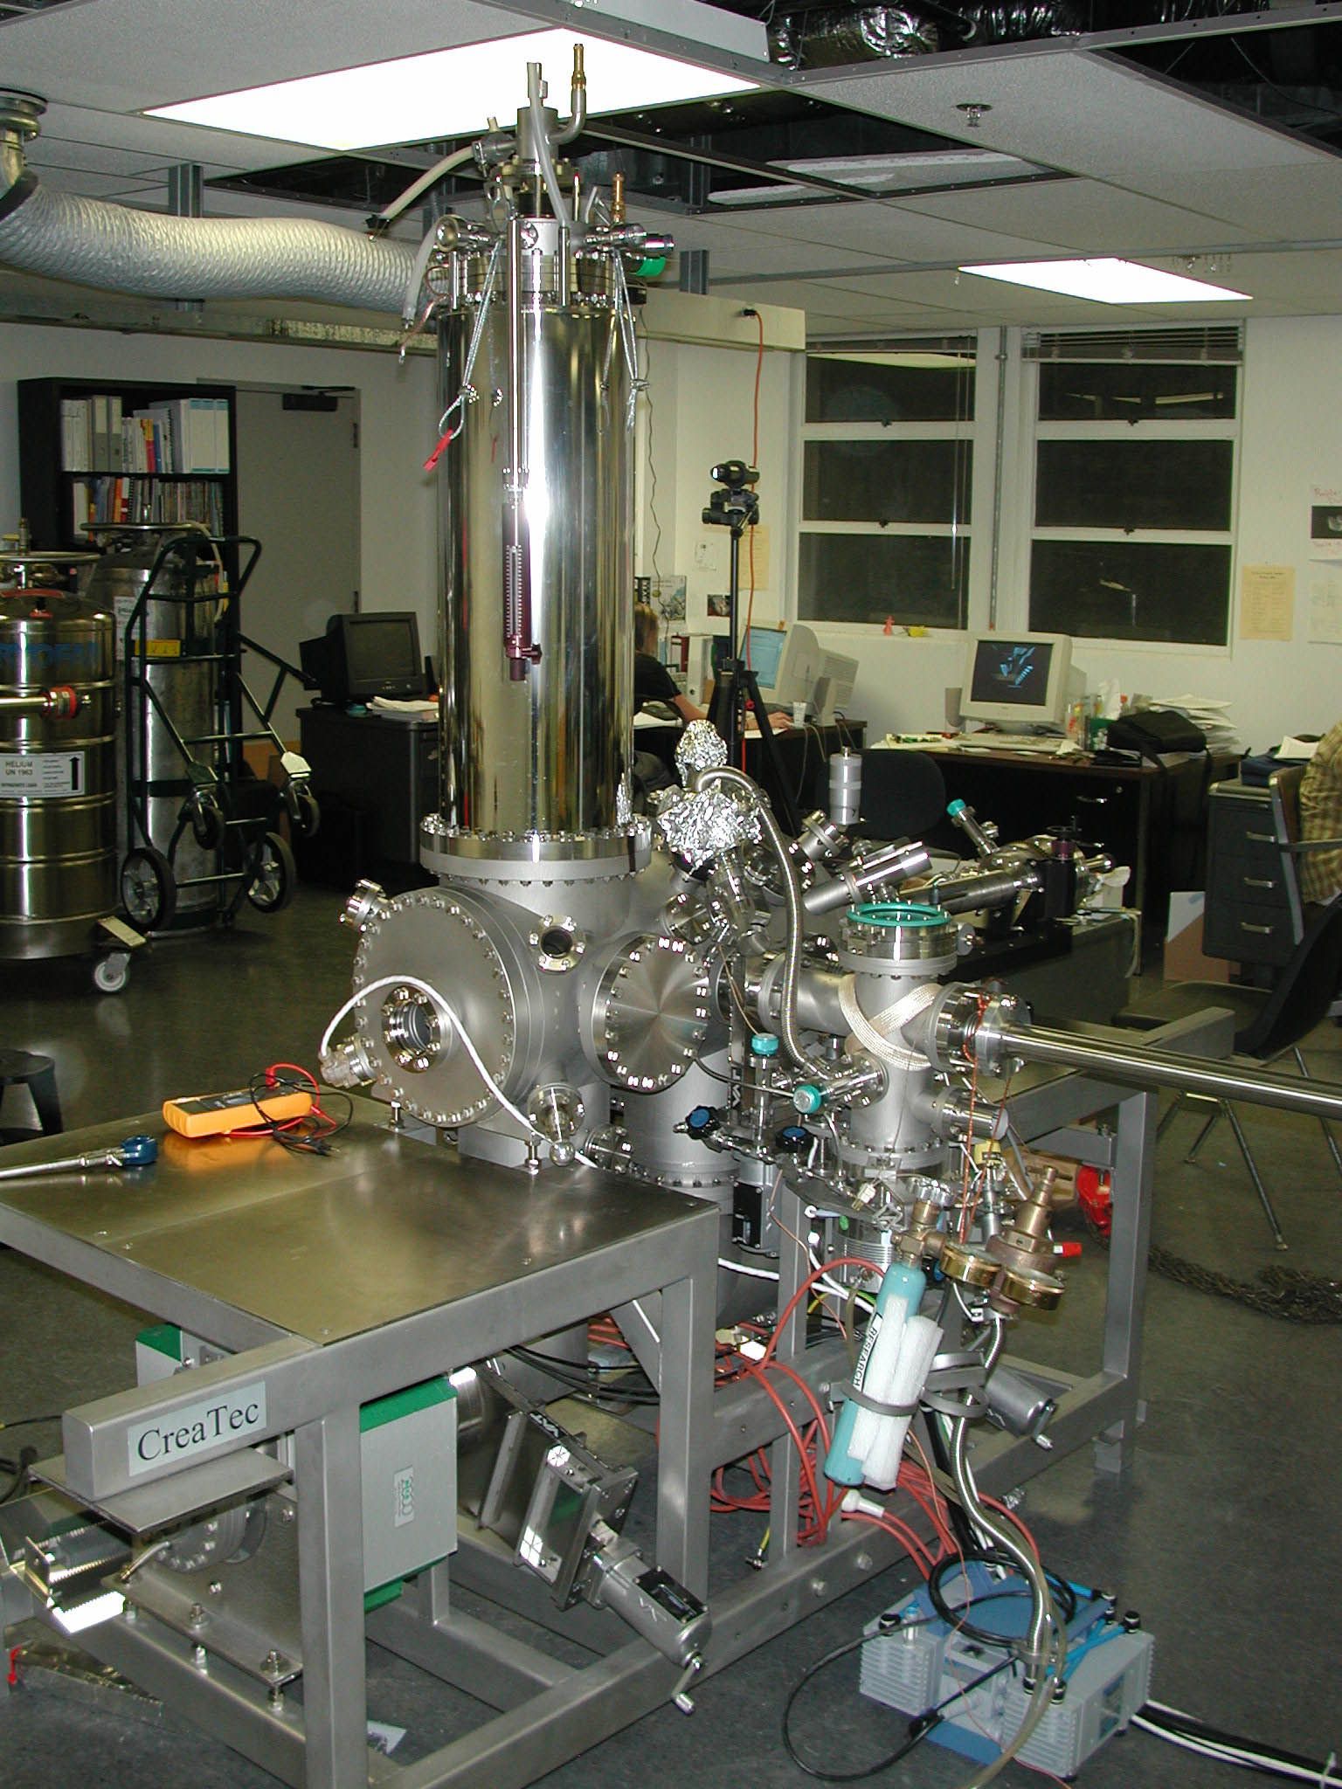

Figure 3. View of a Scanning Tunneling Microscope (STM) at the PICO lab of one of the authors (Gimzewski) at UCLA.

During the early eighties, a dramatic moment happened in microscopy that has led to the rapid growth of nanoscience. It was a simple idea that put the whole concept of lenses into disarray. An IBM team, Henrich Rohrer, Gerd Binning, Christoph Gerber and Eddie Weibel were working on finding pinhole defects in nanometer thin oxide layers that acted as barriers for quantum tunneling for what was known as the Josephson project. Pinholes as tiny as a nanometer shorted out the tunneling process. These were difficult to characterize using traditional microscopes, and the researchers used a tiny needle to contact the oxide layer to probe the electrical properties of the film.



Figure 4. Floating in an aliquot of laboratory test fluid, these hypothetical early medical nanorobots are testing their ability to find and grasp passing virus particles. Courtesy of Jeff Johnson, 2001. Copyright 2003 Hybrid Medical Animation.

Necessity as the mother of invention promulgated the researchers to build a machine where the little needle could be moved across the surface of the oxide film and thereby seek out the pinholes. Thinking about how the new invention worked, led to an important realization scribbled on a lab book. By using electron tunneling as a probe, they realized that mainly the last atom on the needle (the closest on the surface) really sensed the local properties. The needle moving across the surface created a topographic representation, and a few back-of-the-envelope calculations indicated even single atoms could be resolved. What they realized was a major paradigm shift -- rather than using lenses and waves, they were recording by feeling. By 2003, a whole range of microscopes based on tactile sensing had been developed, and many companies were established to manufacture machines that are used by microelectronics and data storage industries. Worldwide sales of these machines are in the range of a billion dollars.
The new tactile techniques opened up a radically new approach to microscopy enabling real local properties to be imaged and mapped. For instance, ultra high-resolution images of local magnetism like bits of north and south directed domains could be obtained with magnetic tips. If friction was an issue, images of local friction as it scanned the surface could be mapped. This opened up a new world, a world never really seen before on those terms – the nanoworld. Even bigger consequences of “touching” rather than looking were also realized.
The environment in which once could image at really high resolving power, with the wave microscopes was limited to a vacuum so that biological objects were dead and perturbed from their natural state. This was a major drawback that limited the interpretation of microscope images of biological samples. The new tactile microscopes were not subject to such limitations. Consequently, it was possible to image in vivo what is under physiological conditions on live specimens. It was possible to image the electrodes of batteries as they worked in their acidic environment. Our windows on the nanoworld looked not at parts of systems, but really at operating fully functional systems, allowing their complexity to be “seen” and measured all the way up from the nanoscale of individual atoms and molecules.
Through the paradigm shift in microscopy, the tactile probes which were now being called scanned probe microscopies (SPM) opened up yet one more feature, which had been the “Holy Grail” of a mad dream. The idea to manipulate and move single atoms and molecules in a controlled manner, up until the mid nineteen eighties, was something outside of general scientific plausibility. In fact, the famous scientist Erwin Schrödinger wrote that we would never experiment with just one electron, atom, or molecule. (1952, pg. 233) This view, like concepts of statistical mechanics which viewed matter as a collective property of atoms and molecules, required a rebel to question its almost religious doctrine. Eight years later, Richard P. Feynman told us that there are no physical limitations to arranging atoms the way we want, but he was pretty alone when he said it (1960, pg. 22).

The Mechanist View: Molecular Nanobots

He was living like an engineer in a mechanical world. No wonder he had become dry as a stone.
- Simone de Beauvoir, The Mandarins

The invention of clocks is commonly accepted as the beginning of our move away from natural cycles. The Benedictine monks invented the clock to regulate the time of devotional prayers, and it was not long before it was incorporated in the town hall to be used by shops and merchants. But the mechanical age does not take full hold on the Western tradition until the mid 1600s, with the Industrial revolution. Thomas Hobbes in 1651 reduced the body to mere mechanical parts, followed by Descartes who placed humans outside of nature, and firmly established the dualism that is still very strong in our society and in the world of science in p`articular. To Descartes, the universe functioned as a giant machine, according to mathematical laws that can be unraveled and controlled. Everything external to the human is there for the human to use and manipulate. This philosophical stance was put to action in science by Newton who extended the machine analogy to all laws of nature. Newtonian physics describes everything from the motion of stars to atomic particles as part of the mechanical structure. Newtonians held that by discovering these laws, men prove their superiority and affirm their natural right to dominate all of matter in nature. During this same time, an English philosopher and statesman Roger Bacon, argued (in support of science) that the purpose of the mechanical arts was to yield profit and societies were formed that funded scientific ventures focused on solving navigational and military problems. There is much more that could be said about the political and economic climate of Europe at this time and how this story has led us to the world we face today, but for the purpose of this paper we will only allude to this connection. Suffice it to say that the clock speeds of computers and the magnification levels of microscopy today far exceed the capabilities of the human biological system, and that clearly we have reached the limit of the mechanical age. This has led some to believe that machines are superior to humans, and that robots would take over the world.
The term robot, as is well known, was first used in a science fiction book entitled Valka s Mloky (War with the Newts), and a play, titled R.U.R (Rozuma Univerzalni Roboti) [rozum means wisdom] (Rozum's Universal Robots), written by Karel Capek in 1920. Capek coined the word robot from a Czech word, robota, meaning drudgery, or compulsory labor. This idea of the robot was assimilated into the science world and developed to the point where robots rove the terrain of Mars and vacuum homes. Perhaps the most controversial persona in the robotic sciences is Hans Moravec, whose visions no doubt compete with science fictions writers. Moravec, a professor of robotics at Carnegie Mellon University, envisions a not-too-distant future in which robots of superhuman intelligence, independent of their human creators, colonize the planets in outer space. He projects that in the next 40 years of robot development, there will be a rise of super-intelligent, creative, emotionally complex cyber-beings, and the end of human labor. He predicts an absolutely mechanistic future trajectory in which robot corporations will reside in outer space and imagines planet-size robots that cruise the solar system looking for smaller bots to assimilate. Eventually every atom in the entire galaxy would be transformed into robotic space, with a full-scale simulation of human civilization running as a subroutine as depicted in the 1999 movie – the Matrix.
These mechanistic ideas are not in the realm of the physical only, but have equally been distributed by the cyber realm in the version of a robot. ‘Bot’, an abbreviation for robot, came into use with the development of autonomous software programs that typically run in the background on the Internet. The first popular version of bots was used in MUDs and MOOs, online social spaces where fact and fiction commonly blur. [10] Many different types of bots emerged, depending on the focus of the program – adbot, knowbot, pokerbot, searchbot, smartbot, spambot, to name a few. It is this train of thought from which the idea of a ‘nanobot’ emerged -- commonly visualized as derivatives of robots on a nanoscale.
In the introduction to Engines of Creation (1986), Drexler turns to a dictionary definition of a machine as “any system, usually of rigid bodies, formed and connected to alter, transmit, and direct applied forces in predetermined manner to accomplish a specific objective, such as the performance of useful work,” and asserts that molecular machines fit this definition quite well. Throughout the book, natural systems are interpreted as machines operating to Newtonian principles, and the nanomeme is firmly established in an mechanical engineering world-view. Proteins, Ribosomes, RNA, DNA and viruses are all part of a grand machine. In 1992, Drexler, who is an engineer by degree, went beyond predicting a general emergence of nanotechnology, wrote another book- Nanosystems: Molecular Machinery, Manufacturing and Computation- detailing technical particulars. Drexler's drawings of nanothings tend to resemble molecule-sized versions of mechanical counterpoints that have been around since the Industrial Revolution: gears, cogs, levers, and pistons. (Gao) If these versions of nanomachines will some day materialize, his engineer's calculations, which hold true in the world most people comprehend, will probably not be of much use in the molecular realm. However, futurist vision includes self-assembled armies of tiny robots that build greater armies of tinier robots, ad infinitum.
The creation of this nanomeme that is currently in circulation has certainly been promulgated by Drexler’s work and later by the Foresight Institute Inc., a futurist organization based in Palo Alto. The concept of nanotechnology in the general public stems in part, from the media’s habitual reliance on the promotions and prognostications of Drexler and his Foresight Institute. The mechanistic nanomeme has taken on the sheen of authority, as one press clipping breeds another. Indeed, the nanomeme is similar the self-replication of the nanobots themselves. Many articles have an inspired tableaux of molecule-sized robots "grabbing atoms one by one" and then replicating armies of themselves. The Foresight Institute website asserts a lot of things, such as- within the foreseeable future, there will be a “nanobox” that manufactures items such as cell phones from a "toner" composed of "electrically conductive molecules"- and so on. In the long run, we will turn dirt into food, ending world hunger, which is another theme that propagated around some nanotechnology enthusiasts who believe it will give humans the power of telepathy. [11]
During the 1950’s and 60’s strategic thinking using “systems analysis” emerged, pioneered by the RAND corporation, a military research and development institution. This was happening at the same time that the greatest discovery in biology occurred—the physical structure of the DNA. Watson and Crick explicitly described DNA in computer terms as the genetic “code,” comparing the egg cell to a computer tape. This school of thought perpetuated in even more extreme terms by proponents of Artificial Life such as Chris Langton, who spoke of separating the “informational content” of life from its “material substrate.” (Langton, 1989) As Richard Coyne noted: “Information is thought to be the essence of life, as in the DNA code. To record and break the code is to have mastery over life.” (Coyne, 1995. pg. 80)
In 1995, the Rand Corp. published a study on the potential of nanotechnology. (Anton) The Rand paper relied heavily on the writings of Drexler and the Foresight Institute. The authors concluded that nanotechnology would best be used to take advantage of indigenous resources found on asteroids, comets, or planets for mining; defending Earth against impacts; or tools to assist extensive colonization of the solar system on a reasonable time scale. Interestingly, ending wars, hunger or solving the energy crisis gets no mention at all.

Weaving Fact and Fiction into Blur

If you want to think of it that way, a human being is actually a giant swarm. Or more precisely, it’s a swarm of swarms, because each organ – blood, liver, and kidneys – is a separate swarm. What we refer to as “body” is really a combination of all these organ swarms. We think of our bodies as solid, but that’s only because we can’t see what is going on at the cellular level. If you could enlarge the human body, blow it up to a vast size, you would see that it is literally nothing but a swirling mass of cells and atoms, clustered together into smaller cells and atoms. (Chrichton, pg. 260)

Michael Crichton’s recent novel, Prey, provides an excellent example of contemporary science fiction that is based on current science. As an acclaimed author of best-selling novels that are almost always converted into blockbuster movies, there is no doubt that he influences the collective imaginary. Prey was almost immediately on the New York Times top five best seller list, and remained there for weeks. Rights for a movie were bought by twentieth Century Fox before the book was completed and in September 2002, the author signed an partnership agreement with SEGA to develop a game scheduled to be released in 2004. Crichton takes four separate fields, distributed processing for networked computing, nanotechnology or, molecular manufacturing, biotechnology and the behavioral science of socially organized insect communities, such as bees and ants. By tying in the evolution process, he comes up with a very plausible scenario and some possible "Particle Swarm Organization" applications. As he says in his foreword: "Sometime in the twenty-first century, our self-deluded recklessness will collide with our growing technological power."
Crichton includes in his novel many references to current histories and skillfully weaves them into the story, blurring fact and fiction. For instance, the main character who narrates the story describes how scientists (Don Eigler and co-workers) at IBM repositioned Xenon atoms with an STM tip to form the letters of the company logo. (Eigler, 1990) In his narrative, he also comments that this was more of a stunt than anything else, and that it would take much more to create new technology. The description of the building molecular assemblers in the book is directly inspired by Drexler’s visions of nanobots. After laying down a foundation based on actual events, the author proceeds to tell the story of a company that succeeds in building molecular assemblers that eventually go out of control.
After referencing events, people and companies many of us are familiar with, we are taken on a horror ride that instills a real fear of nanotechnology. This and many other works of science fiction that have appeared in the movies, on TV programs, books and PC games reflect the concept of nanotechnology as “more” than science or hard technology. It has actually evolved into a culture and art form in its own right. Even more than cyborgs, AI or robots, nanotechnology truly traverses science and art as the dream of the future. This novel will first be read by millions, then will be watched in movies and played in games, until it finally becomes another part of the collective nano-consciousness.
It is also notable that scientists have honored Crichton by actually naming a new species of dinosaur after him. Scientists at the Institute of Vertebrate Paleontology and Paleo-anthropology, of the Chinese Academy of Sciences named a new ankylosaurus species “Crichtonsaurus bohlini” in honor of Crichton and Birger Bohlin, a Swedish paleontologist. The three-yard-long fossil of an armor-plated vegetarian, discovered in northeast Liaoning Province, is estimated to date from 90 million to 100 million years ago. (Chrichton, 2002)

Dark Visions
In 1739, Voltaire wrote a diminutive science fiction about microbes, men and beings from outer space. The story was entitled Micromegas (from the Greek small/great) was written while he was living at a humanist retreat dedicated to the science of Newton and the philosophy of Locke. The philosophers are visited by aliens who are introduced to a world that is hugely affected by the new discovery of microscopy. The microscope in Voltaire’s book, similar to the STM today, challenged accepted reasoning and belief systems. Amazingly, in this story, we have also fiction based on the science of its day, but, set in a time plagued by wars. Specifically, during the writing of Micromegas, the Russo/Austrian – Turkish war was underway (1736-39), and the aliens are told that these new discoveries about matter will be used for evil, for that is what men do: “We have more than enough matter to do plenty of evil, if evil comes from matter; and too much of evil, if evil comes from the spirit. For instance, do you realize that as I speak a hundred thousand lunatics of our species, wearing helmets, are busy killing and being killed by a hundred thousand other animals in turbans, and that everywhere on Earth this is how we have carried on since time immemorial?” (Voltaire, pg. 30)
Public conceptions of nanotechnology and the blurring of fact and fiction seem to go hand-in-hand more than in any other science. As nanoscience is being established, it is clear that the imagination is there to roam the many dark visions connected to the military’s interest in nanotech, and soon we are also in the midst of a new type of “war” that will not only require new tactics, but also new technologies. Almost immediately after the 9/11 World Trade Center attack, there were numerous scares of the use of anthrax, with many news reports speculating on the use of biological weapons.
Anticipating such a scenario, the US Army is also collaborating with MIT, having recently promised the university $50 million for a new Institute for Soldier Nanotechnologies (ISN). The aim is to improve soldiers' protection and their ability to survive using new tiny technologies to detect threats, and automatically treat some medical conditions. The Army isn't the only branch of the military actively developing smart textiles. The US Navy funded a project in 1996 that eventually turned into the Smart Shirt, a product commercialized by SensaTex Inc. in Atlanta, with technology from Georgia Tech Research Corp. The T-shirt functions like a computer, with optical and conductive fibers integrated into the garment. It can monitor vital signs, such as heart rate and breathing of wearers, and will most likely be first put to use by law enforcement officers and military personnel. (Kary)

From Nanobots to Nanobods

Wisdom requires a new orientation of science and technology towards the organic, the gentle, the non-violent, the elegant and beautiful. (Schumacher, 1973. pg. 27.)

Does it really make sense to extend the idea of a mechanical robot to software program bots and apply a Newtonian/ industrial-age approach to work on the molecular level? More and more researchers working on this scale are looking closely at natural biological systems for clues and inspiration. In this vision of bio-inspired nanotechnology, the body and mind shift to another paradigm and certainly appear much more appropriate to the new century we have just entered.
Schumacher, an economist, in Small is Beautiful, maintains that the prevalent pursuit of profit and progress, which promotes giant organizations and increased specialization, has in fact resulted in gross economic inefficiency, environmental pollution, and inhumane working conditions. With the emphasis on “person not product”, he points the way to a world in which capital serves people instead of people serving capital. Around the same time, Buckminster Fuller, an engineer, moved away from the mechanistic view, by studying carefully natural systems (that also appeared on the molecular scale with the later discovery of the c60 molecule). (Fuller, 1975) Recently, Smalley, one of the Nobel Laureates who discovered buckminsterfullerene, responded to the well-established nanomenes by pointing out that the main problem with the world at the moment needs to be addressed is the energy crisis. He stopped short of connecting nanotech to this problem, but certainly has made a significant attempt to shift the discourse of the current hype. [12]
With the increasing computing power, research of the invisible realm increased at an accelerated pace at the end of the 20th Century. In addition to the decoding of the human genome and the discovery of a new form of carbon, new type of life is also being found. One such recently discovered creature does not fit into any previous category of life was found in an undersea vent north of Iceland. These creatures, formally known as Nanoarchaeum equitans, may represent an entirely new grouping within Archaea, the most mysterious of life's three domains. Thy are small spheres attached to other organisms and are so genetically strange and so tiny--smaller than a grain of sand and about the width of four human hairs--that they were invisible to traditional ecological survey methods. Even the ultimate molecular ecology methods could not detect these new microbes because they are so different from everything known so far. Karl Stetter, a professor of microbiology at the University of Regensburg in Germany who led the discovery team, and his colleagues detected the creatures only after growing them in hot, oxygen-free and high-pressure conditions to simulate their natural hostile environments. The DNA of the "nano-sized hyperthermophilic archaeon" is interesting because it is so minimal -- containing just 500 kilobases. The genome is among the smallest known to date. There are 6 million kilobases for humans and 9 million for corn. (The others are eukaryotes--organisms with nucleated cells like people, plants and fungi--and bacteria.) (Huber, 2002. pg. 63)
We should take a closer look at ourselves as magnificent nano-beings, connected and part of an entire living body of this Earth and beyond for inspiration, not to machines of the past. DNA, proteins, and cells of all sorts already function at nanoscale in animals and plants, and they work at normal temperatures. In our view, the nanobots of the past with their mechanical structures, batteries, motors and so on are evolving into ‘nanobods’ – a closer reflection of our human condition in which living nanoscale chemical-mechanical elements are connected in ever increasing complexity along the principle of cells, the smallest general unit of life capable of autonomous replication.

Conclusion -- nano fact & fiction: being in between
Nanotechnology works at a scale where biotech, chemistry, physics, electrical and mechanical engineering converge, and thus has real potential to impact every aspect of our lives. We will see an impact on everything from our social systems to buildings, furniture, clothes, medicine, bodies and minds. But most of all, where we believe it will make a fundamental shift is in our conscious and unconscious minds. As the perception of reality shifts to the collective level, we will find ourselves in an entirely new world, with very different values and motivations. However, we do acknowledge that any radical proposition, with such enormous and global implications, will undoubtedly have to face fierce opposition from those who have so much invested in the old, mechanistic, world-view. We have witnessed, in the 20th century, many great innovations have been squashed by corporate, industrial and national interests – transportation and energy being at the top of the list. It appears to us that resistance to a technology that will change fundamentally the way humans think, may be much greater, given the usual time period of 20-50 years it takes for technology to penetrate into the general society. We are about to witness some great ideological struggles, much greater than what we have seen in past centuries. Indeed, the stage has already been set for this new era with the basic moral and rights to own one’s genetic code, exemplified by the patenting of genes and the cloning of human beings.
In nanotechnology, the blurring of fact and fiction is very much part of the developing narrative in the construction of a new science and industry. This blurring is not necessarily negative and has a potential to connect media arts, literature and science in many new and interesting ways. Art, literature and science working together is certainly a powerful combination that should be nurtured in education on all levels. As common technologies are being used in arts, sciences and practically all disciplines, borders are becoming increasingly indiscernible, and we have to be more conscious than ever of the metaphors being generated. The barriers between disciplines and people in them are more or less psychological. Currently, the vast majority of stories and imagery being circulated in the public realm are based on 20th century thinking that is largely centered on machines. Nanoscale science and media art are powerful synergies that can promulgate the 21st century emergence of a new 3rd culture, embracing biologically inspired shifts, new aesthetics and definitions.

Notes
[1] Norio Taniguchi of Tokyo science University first defined nanotechnology in 1974 (N. Taniguchi, "On the Basic Concept of 'NanoTechnology'," Proc. Intl. Conf. Prod. Eng. Tokyo, Part II, Japan Society of Precision Engineering, 1974).

[2] Kroto, H. Nanoeterscale Architecture. IN The proceedings of The Second International Symposium on Nanoarchitectonics Using Suprainterationcs (NASI2), (2002) 26-28, March. University of California, Los Angeles.

[3] To address this need, together with Katherine Hayles, the authors have joined forces and created SINAPSE, a non-center that is devoted to promoting collaborations of creative thinkers in arts, sciences and humanities. In November, 2002, together with UC DARNET (Digital Arts Research Network), SINAPSE co-sponsored a conference entitled “From Networks to Nanosystems” that was attended by media artists connected to the CAiiA-STAR programme and scientists from UCLA. See: http://sinapse.arts.ucla.edu; Martin, S. (2002) Towards a Collaborative Culture. UCLA Arts, 6, pp. 3-5.

[4] Taylor, J.M. (2002) New Dimensions for Manufacturing: A UK Strategy for Nanotechnology Department of Trade and Industry, London.; Bainbridge, M.C. Roco ,W.S. ed (2002) Converging Technologies for Improving Human Performances: Nanotechnology, Biotechnology, Information Technology and Cognitive Science. NSF/DOC sponsored report, Arlington, VA., June.; Tolles, W.M. (1994) Nanoscience and Nanotechnology in Europe. Navel Research Laboratory, NRL/FR1003-94-9755, 30, December.; Holister, P. Harper, T.E. (2002) The Nanotechnology Opportunity Report. CMP Cientificia, No. 1 and 2, March.

[5] NASA Ames' have advanced computational molecular nanotechnology capabilities to design and computationally test atomically precise electronic, mechanical and other components and work with experimentalists to advance physical capabilities see: http://www.nas.nasa.gov/
Groups/SciTech/nano/index.html

[5] UCLA and NASA have partnered to combine the latest advances in biology and engineering at the Institute for Cell Mimetic Space Exploration (CMISE). CMISE will identify, develop, promote, and commercialize nano-, bio-, and information technologies for sensing, control, and integration of complex multilevel natural and artificial systems. http://www.cmise.ucla.edu/

[6] Feynman was known to challenge authority and caused consternation in his years with the Manhattan Project, which developed the atomic bomb, by figuring out in his spare time how to pick the locks on filing cabinets that contained classified information. Without removing anything, he left taunting notes to let officials know that their security system had been breached. In 1965, Feynman was awarded the Nobel Prize, along with Shinichero Tomonaga of Japan and Julian Schwinger of Harvard University. The three had worked independently on problems in the theory of quantum electrodynamics, which describes how atoms produce radiation. He reconstructed almost the whole of quantum mechanics and electrodynamics, deriving a way to analyze atomic interactions through pictorial diagrams, a method that is still used widely.

[7] For more information on the history of microscopy, see: S. Bradbury (1968), The Microscope Past and Present, London: Pergamon Press; E. Hunter (1993), Practical Electron Microscopy: a Beginner’s Illustrated Guide, Cambridge: Cambridge University Press; P.D. Brown, D. McMullan, T. Mulvey and K.C.A. Smith (1996), ‘On the origins of the first commercial transmission and scanning electron microscopes in the UK’, Prc. Royal Microscopical Society, 21/32 (1996), p. 161.

[8] For more information on the STM see: Besenbacher, F. 1996) Scanning tunneling microscopy studies of metal surfaces. Rep. Prog. Phys., 59, pp. 1737-1802; Stroscio, J.A., Kaiser, M.J., ed (1993) Scanning Tunneling Microspectroscopy. 27, San Diego, Academic Press, Inc.

[9] For more information on the molecular manipulation using the STM, see: Crommie, M.F. Lutz, C.P. Eigler, D.M (1993) Imaging Standing Waves in a two-dimentional electron gas. Nature, 363, p. 524.; Eigler, D.M. Schweizer, E.K. (1990) Positioning Single Atoms with a Scanning Tunneling Microscope. Nature 344, p.524.; Eigler, D.M. Lutz, C.P. Rudge, W.E. (1991) An Atomic Switch Realized with the Scanning Tunneling Microscope. Nature 352, p.600. ; Gimzewski, J. Joachim, C. (1999) Nanoscale Science of Single Molecules Using Local Probes. Science 283(5408), 1683-1688.; Gimzewski, J. (1997) Atoms Get a Big Push, or is That a Pull? Physic World, November, pp. 27-28.; Cuberes, M.T. Schlittler, R.R. Gimzewski, J.K. (1996) Room–Temperature Repositioning of Individual C60 Molecules at Cu Steps: Operation of a Molecular Counting Device. Appl. Phys. Lett. 69(20), pp. 3016-3018.

[10] A MUD or a ‘Multi-User Dungeon’ is an inventively structured social experience on the Internet, managed by a computer program and often involving a loosely organized context or theme, such as a rambling old castle with many rooms or a period in national history. MUDs existed prior to the World Wide Web, accessible through telnet to a computer that hosted the MUD. A MOO is an Object Oriented MUD, ie the programming language allows you to create “objects” and follows the same principle. Today, many MUDs and MOOs can be accessed through a Web site and are better known as "3-D worlds.

[11] See: http://www.foresight.org/

[12] Professor Richard E. Smalley made this statement at the 16th ANNUAL GLENN T. SEABORG SYMPOSIUM October 26, 2002 in a lecture, “Bandgap Fluorescence from Buckytubes”

References
Anton, P.S. (2001) The Global technology revolution: bio/nano/materials trends and their synergies with information technology by 2015, Santa Monica, CA, RAND.

Applewhite, E.J. (1995) The Naming of the Buckminsterfullerene. The Chemical Intelligencer, 1, (3).

Binnig, G. Rohrer, H. (1999) In touch with atoms. Rev. Mod. Phys. 71, pp. S324.

De Beauvoir, S. (1954) Mandarins. Norton & Company

Capek, K (1970). R.U.R. and Insect Play. Pocket Books.

Capek, K. 1936 (in Czech). War With the Newts. May 1967, Berkley Medallion Edition Paperback. Translated by M. & R. Weatherall; March 1990, Catbird Press paperback; October 1996, Northwestern University Press paperback

Crichton, M. (2002) Prey, New York, Harper Collins.

Crichton, M. (2002) World Briefing | Asia: China: Science Nods To Dinosaur Fiction. New York Times, 11th December, p. 8.

Coyne, R. (1995) Designing Information Technology in the Postmodern Age. Boston. MIT Press.

Drexler, K.E. (1986) Engines of Creation, Garden City, NY, Anchor Press/Doubleday.

Drexler, K.E. (1992) Nanosystems: Molecular Machinery, Manufacturing, and Computation. New York, John Wiley & Sons, Inc.

Feynman, R. (1993) Infinitesimal Machinery. J. Microelectromechanical Sys, 2, pp. 4-14.

Feyman, r.p. (1960) There’s Plenty of Room at the Bottom. Sci. Eng. 23. p. 22

Fuller, R.B. 1975. Synergetics Dictionary. McMillan Press.

Gao, G. Cagin, T. Goddard III, W.A. Globus, A. Merkle, R. Drexler, K.E. (1996) Molecular Dynamics Simulations of Molecular Planetary Gears. IN: First Electronic Molecular Modelling & Graphics Society Conference.

Ghiradella, H. (1991) Light and color on the wing: architecture and development of iridescent butterfly mirrors. Applied Optics, 30: 3492-3500. Applied Optics, 30, pp. 3492-500.

Huber, H. et al. (2002) A new phylum of Archaea represented by a nanosized hyperthermophilic symbiont.” Nature. 417, 63 - 67.

Jung, T. A. Schlittler, R. R. Gimzewski, J. K. Tang, H. Joachim, C. Jung, T. A. (1996) Controlled Room-Temperature Positions of Individual Molecules: Molecular Flexure and Motion. Science, 271 (5246), pp. 181-184.

Kary, T. (2002) MIT to make “nanotech” Army Wear. CNET News.com 14th March.

Langton, C. (1989) Artificial Life. Redwood City, Addison-Wesley.

Moravec, H. (1986) Book Review: Engines of Creation by Eric K. Drexler. Technology Review, 89, (7) pp. 76-77.

Schrodinger, E. (1952) What is Life. Br. J. Philos. 3, p. 233.

Schumacher, E. F. (1973) Small is Beautiful, Economics As If People Mattered. Trade Paperback.

Voltaire, F. (1994) Micromegas and Other Short Fictions, Penguin Classic.

Whitfield, J. (2002) New Bug found on bug: Marine microbe sets miniaturization records. Nature, Science Update.

Yablonovitch, J. Phys. Photonic Band-gap Crystals [Condensed Matter] 5 2443 (1993).

Further reading
Bear, G. (1996) Blood Music.IN: Visions of Wonder: The Science Fiction Research Association Anthology. Hartwell, G., Wolf, M. ed. New York. Tom Doherty Associates.

Crandall, B.C., Lewis, J. ed. (1992) Nanotechnology: research and perspectives: papers from the First Foresight Conference on Nanotechnology. Cambridge, MA, MIT Press, p. 381.

Crichton, M. (2002) Could Tiny Machines Rule the World? Parade: The Sunday Newspaper Magazine, 24th November, pp. 6-8.

Crommie, M.F. Lutz, C.P. Eigler, D.M. (1993) Confinement of electrons to quantum corrals on a metal surface. Science, 262, p. 218.

Cuberes, M.T. Schlittler, R.R. Gimzewski, J.K. (1996) Room–Temperature Repositioning of Individual C60 Molecules at Cu Steps: Operation of a Molecular Counting Device. Appl. Phys. Lett. 69(20), pp. 3016-3018.

Freitas, R. (2001) Robots in the bloodstream: the promise of nanomedicine. Novartis Journal Pathways, October/December.

Freitas, R.A. (1999) Nanomedicine. Austin, TX, Landes Bioscience.

Gimzewski, J. (2002) Nanoarchitectonics. IN: The Proceedings of The Second International Symposium on Nanoarchitectonics using Suprainterationcs (NASI2), University of Califonria, Los Angeles, 26-28, March.

Gimzewski, J. (2001) Taking a small look at life. Engineering and Physical Sciences Research Council (EPSRC) keynote address, London, 19th March.

Gimzewski, J. Joachim, C. (1999) Nanoscale Science of Single Molecules Using Local Probes. Science 283(5408), 1683-1688.

Gimzewski, J. (1997) Atoms Get a Big Push, or is That a Pull? Physic World, November, pp. 27-28.

Gimzewski, J. (1999) Nanoelectronics. McGraw-Hill Yearbook of Science and Technology 2000 pp. 274-278.

Gimzewski, J.K. Joachim, C. Schlittler, R.R. Langlais, V. Tang, H. Johannsen, I. (1999) Rotation of a Single Molecule within a Supramolecular Bearing. Science, 283(5408), pp. 1683-1688.

Gross, M. (1999) Travels to the nanoworld: miniature machinery in nature and technology. New York, Plenum Trade.

Lee, J.L. (2003) Nanotechnology inspires joining of art, science. The Daily Bruin, 4th February p. 4.

Lyo, I.-W. Avouris, Ph. (1991) Field Induced Nanometer to Atomic Scale Manipulation of si Surfaces with the Scanning Tunneling Microscope. Science, 253, 173.

Mulhall, D., Our molecular future: how nanotechnology, robotics, genetics, and artificial intelligence will transform the world, Amherst, NY: Prometheus Books (2002).

Pearson, H. (2002) Bugs trained to build circuit: bacteria lay bricks on nano scale building site.Nature, Science Update.

Ratner, M.A. (2003) Nanotechnology: a gentle introduction to the next big idea, Upper Saddle River, NJ, Prentice Hall.

Sundman, J.F.X. (1999) Acts of the Apostles, Rosalita Associates.

Timp, G. ed. (1999) Nanotechnology. New York, AIP Press.

Vesna, V. Gimzewski, J. (2002) Networks to Nanosystems, 9/11-N2N: Art, Science & Technology in Times of Crisis, University of California, Los Angeles, 14th November 14, 2002.

Vesna, V. Gimzewski, J. (2003) Zero@Wavefunction. an art/science installation, University of California, Los Angeles, 29th January.

Vesna, V. From Networks to Nanosystems. IN: The proceedings of The Second International Symposium on Nanoarchitectonics Using Suprainterationcs (NASI2), (2002) 26-28, March. University of California, Los Angeles.

Wilson, R.C. (1990) The Divide. New York, Doubleday.

Wilson, M. (2002) Nanotechnology: basic science and emerging technologies Boca Raton, FL, Chapman & Hall/CRC.

Yan, P. (1993) The All Star Buckyball. Scientific American, 269, p. 46.

